**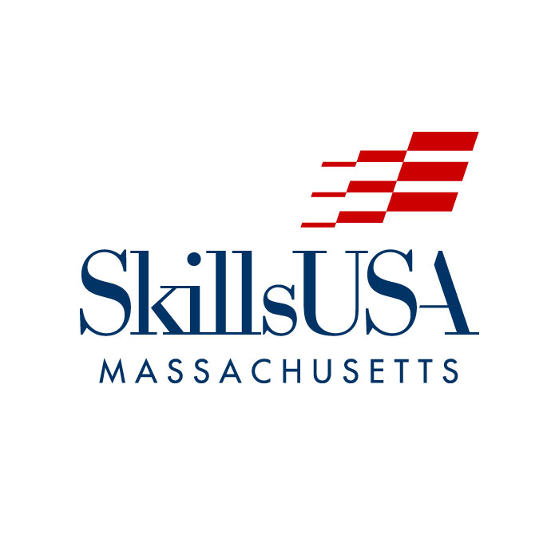****SkillsUSA Massachusetts, Inc.**

**Major Conferences & Meetings Schedule**

**2024-2025**

**Board of Directors Meetings**

* **October 17, 2024** – Tri-County RTHS, Franklin, MA - 2:00 p.m. – 4:30 p.m.
* **December 19, 2024** – 3 Restaurant, Franklin, MA 12:00 noon – 2:30 p.m.
* **January 23, 2025** – Via ZOOM - 2:00 p.m. – 4:30 p.m.
* **March 20, 2025** – Tri-County RTHS, Franklin, MA - 2:00 p.m. – 4:30 p.m.
* **May 29, 2025** – Tri-County RTHS, Franklin, MA - 2:00 p.m. – 4:30 p.m.

**SkillsUSA Championships Planning**

**Meetings/Series Director’s Meetings**

* **October 23, 2024** – Planning Meeting – via ZOOM 4:00 p.m. – 6:00 p.m.
* **November 20, 2024** – Planning Meeting – via ZOOM 4:00 p.m. – 6:00 p.m.
* **January 29, 2025** – Planning Meeting – via ZOOM 4:00 p.m. – 6:00 p.m.
* **March 26, 2025** – Scoring Training/Planning Meeting - Blackstone Valley Technical HS, 65 Pleasant Street, Upton, MA 01568 4:00 p.m. – 6:00 p.m.
* **April 30, 2025** – State Conference – Series Director Check-in and Kick-off Dinner Best Western Hotel & Trade Center, 181 Boston Post Road, west Marlborough, MA 01752

**State Officer Meetings**

* **September 14, 2024** – SkillsUSA State Office, Raynham, MA 9:00 a.m. – 1:00 p.m.
* **October 4-6, 2024** – Region I Summit, Hershey, Pennsylvania 7:30 AM – Fri - 2:00 PM Sun
* **November 9, 2024** – via ZOOM with FSLC Staff 9:00 a.m. – 12:00 p.m.
* **December 14, 2024** – Holiday Party, Shawsheen Valley Technical HS, Billerica, MA 9:00 a.m. – 2:00 p.m.
* **January 11, 2025** – SkillsUSA State Office, Raynham, MA 9:00 a.m. – 1:00 p.m.
* **March 29, 2025** – Portrait Day, Courtyard Marriott, Marlborough, MA 9:00 a.m. – 3:00 p.m.
* **April 23, 2025** – SkillsUSA State Office, Raynham, MA 9:00 a.m. – 3:00 p.m.
* **June 10, 2025** – via ZOOM [National Delegate Meeting] 4:00 p.m. – 6:00 p.m.

State Officer Meetings

September 11, 2021 – Southeastern RTHS, South Easton, MA - 9:00 a.m. – 1:00 p.m.

October 16, 2021 – Southeastern RTHS, South Easton, MA - 9:00 a.m. – 1:00 p.m.

November 13, 2021 – via ZOOM - 9:00 a.m. – 1:00 p.m.

December 11, 2021 – Holiday Party, South Shore RTHS, Hanover 9:00 a.m. – 2:00 p.m.

January 22, 2022 – via ZOOM - - 9:00 a.m. – 1:00 p.m.

February 23, 2022 – Southeastern RTHS, South Easton, MA - 9:00 a.m. – 3:00 p.m.

March 26, 2022 – Portrait Day, Best Western Hotel, Marlborough, MA 9:00 a.m. – 2:00 p.m.

April 20 & 21, 2022 – Southeastern RTHS, South Easton, MA - 9:00 a.m. – 3:00 p.m.

May 21, 2022 – Southeastern RTHS, South Easton, MA - 9:00 a.m. – 2:00 p.m.

**Major Conferences & Events**

**Friday-Sunday, September 6, 7 & 8, 2024**

SkillsUSA Massachusetts Staff Planning Retreat (**SkillsUSA Massachusetts staff**)

Boston, MA

**Friday-Wednesday, September 21-25, 2024**

Washington Leadership Training Institute (**state & national officers**)

Alexandria, Virginia/Washington D.C.

**Friday-Saturday, October 4-6, 2024**

Region 1 State Leaders Conference

Hershey, Pennsylvania

Travel begins at 7:30 AM on Friday

**Thursday, October 10, 2024**

Chapter Advisor’s Boot Camp & Kick-off Luncheon

Courtyard by Marriott – Boston Marlborough - Marlborough, MA 01753

8:30 a.m.-3::00 p.m.

**Tuesday, October 29, 2024**

MRE Challenge (**for culinary students**)

Massachusetts Army National Guard Armory-149 Speen Street, Natick, MA 01760

**Sunday-Monday, November 24-25, 2024**

Staff days: Friday-Saturday, November 22-23, 2024

Fall State Leadership Conference

Best Western Royal Plaza Hotel

181 Boston Post Road, West - Marlborough, MA 01753

**Saturday, December 14, 2024**

SkillsUSA Community Holiday Party

Shawsheen Valley Technical HS

100 Cook Street, Billerica, MA 01821 PH: 978.667.2111

**Thursday, January 16, 2025**

SmartStart Summit (**for freshman students**)

Location: TBD

**Thursday, February 6, 2025**

SAiL *(Senior Adventures in Leadership)* Conference

Location: Gillette Stadium, 1 Patriot Place, Foxborough, MA

**Wednesday, February 26, 2025**

District 3 Conference

On-line Qualifying Event

**Thursday, February 27, 2025**

District 2 Conference

On-line Qualifying Event

**SkillsUSA Massachusetts ♦ 501 Paramount Drive, Raynham, Ma 02767 ♦ (508) 738-2474 ♦ www.maskillsusa.org ♦ kward@maskillsusa.org**

**Friday, February 28, 2025**

District 1 Conference

On-line Qualifying Event

**Tuesday, March 11, 2025**

District 6 Conference

On-line Qualifying Event

**Wednesday, March 12, 2025**

District 5 Conference

On-line Qualifying Event

**Thursday, March 13, 2025**

District 4 Conference

On-line Qualifying Event

**Thursday, April 10, 2025**

Outstanding CTE Student Awards Banquet

Mechanics Hall, Worcester, MA

**Thursday-Saturday, May 1, 2 & 3, 2025**

Staff days: Monday-Wednesday, April 28-30, 2025

State Leadership & Skills Conference

Best Western Royal Plaza Hotel

181 Boston Post Road, West, Marlborough, MA 01753

Blackstone Valley RTHS, 65 Pleasant Street, Upton, MA 01568-1499 PH: 508-529-7758

Hampton Inn, Embassy Suites Hotel, Courtyard Marriott. Hotel, Westford Regency Hotel

**Thursday, June 12, 2025**

Chapter Advisor’s NLSC Lunch & Learn

Courtyard by Marriott – Boston Marlborough - Marlborough, MA 01753

10:00 a.m.-2:00 p.m.

**June 23-28, 2025**

Staff days: Friday-Sunday, June 20-22, 2025

National Leadership & Skills Conference

Georgia World Congress Center, Atlanta, Georgia

**June 25-26, 2025**

Connecting for Success Conference

Assabet Valley RTHS

215 Fitchburg Street - Marlborough, MA 01752 PH: 508-485-9430



**Sunday-Thursday, July 20-24, 2025**

State Officer Training

Courtyard by Marriott – Boston Marlborough - Marlborough, MA 01753

**Tuesday-Sunday, September 10-15, 2024**

WorldSkills Lyon – Lyon, France